
GREYT EASTER
MEET & GREET
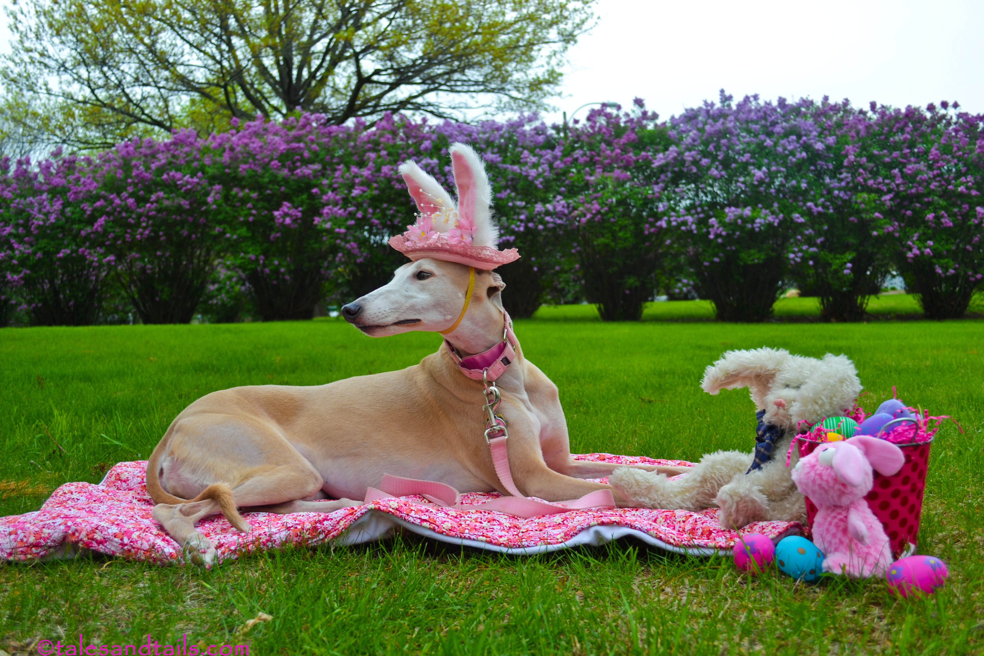

MEMORIAL HALL

OSWESTRY
SATURDAY APRIL 11TH
10.00AM-200PM
Come and meet the Greyhounds and join in some Easter fun.
Lots of goodies to buy, games to play and refreshments and cakes to indulge in.
www.greyhoundtrustshropshireandborders.co.uk
Facebook :Greyhound Trust Shropshire & Borders

